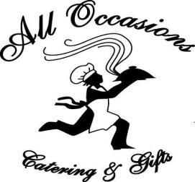
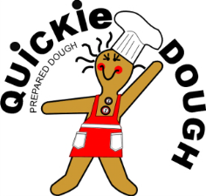
C & R Distribution
Home of Quickie Dough & All Occasions Catering
(902) 469-1927
obbhalifax@eastlink.ca
www.alloccasionscateringandgftbaskets.ca

Does your group need to raise extra funds?
Here at Quickie Dough, we make a unique variety of fully prepared dough for you to sell through fundraising campaigns. Just like you would do at home, our homemade recipes are prepared from scratch and contain the same ingredients found in most household kitchens.

A Most Unique Cookie Dough Fundraiser!

OUR VARIETY INCLUDES

Traditional Recipes Lite & Nutritious Critter Crunchies Darn Near Gluten Free
(School Approved) (Dog Biscuits) (traces of gluten are present)

*Our Darn Near Gluten Free cookies are made with gluten-free ingredients, however,
other gluten products are prepared using the same equipment, so, traces of gluten are most likely present.

Information about Quickie Dough and holding a fundraiser;
Highlights:.
- Our homemade recipes are prepared from scratch .
- You receive your dough frozen. Quickie Dough can be thawed and re-frozen.
- Our’ Lite & Nutritious’ brand products are school friendly.
- No peanut products are used in our recipes. However, some of our ingredients may contain trace amounts.
- All Products contain dairy – except for # 5 Sugar Cookies
- All products contain Egg – except for # 16 Shortbread Cookies
- We use gluten free flour in our Darn Near Gluten Free cookies, however, as we prepare other wheat products in our facility
traces of wheat are very possibly present.

Procedures:
- When you are ready to start your campaign, just print pages one and two of the attached Collection Sheet back-to-back and
now you are ready to get your campaign rolling.
- We suggest that you run your campaign for at least two weeks.
- Delivery of your order will be within approximately 14 days after placement of order. Delivery charges
may apply depending on the size and location of your order.
- Please be sure to notify us if you decide to start a campaign.

Ending your campaign:
- When you have ended your campaign and collected all your orders you will do a tally of each type of dough that you require
from your combined orders and then complete the attached Order Form showing how many of each variety is required.

- Once we receive your order we will send you a copy of your invoice and give you a date of when your order will be ready for
pick-up or delivery

Payment:
- Payment is not due until you are in receipt of your order, unless otherwise indicated.
We accept cash, cheque, money order, or e-transfer payment. Should you wish to pay by cheque we will accept one check only, payable from you/your group, payable to C&R Distribution. We will not accept individual cheques from your customers..

We look forward to assisting you with a fundraising campaign which is sure to be successful! Should you have any questions or concerns, please don’t hesitate to contact us.

Packaging

Quickie Dough is packaged in a re-usable, recyclable, plastic tub which holds 2.2 pounds of dough and will make approximately 40 ¾ oz. cookies. Master cases of 16 are available

Fundraising Pricing

 | Single Tub price | Selling Price | Profit per tub
Traditional  Lite & Nutritious  Critter Crunchies  Items #1-12 | $7.00 | $11.00 | $ 4.00
Darn Near Gluten Free  Items # 13-15 | $ 8.00 | $ 12.00 | $ 4.00
Shortbread  Item #16 | $ 10.00 | $ 14.00 | $ 4.00

Subject to change without notice March 2018

